2017 BenQ International Sculpture Workshop
Entry Prospectus

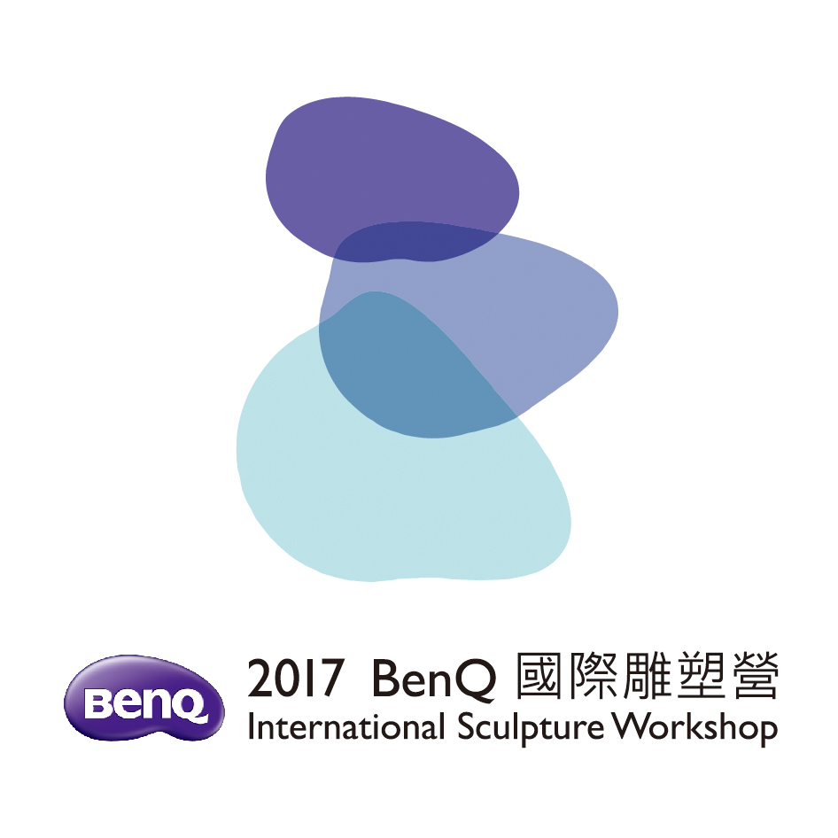

Title: 2017 BenQ International Sculpture Workshop

Curator: Mr. Chiu, Tai Yang

Organizer: BenQ Foundation

Co-Organizer: Hanho Art Co.

1. Purpose
With the event of 2017 BenQ International Sculpture Workshop, it can be provided as a stage to create sculptures, promote the art and cultural exchange, deeply incubate modern sculpture in Taiwan and open the boundary-spanning and diversified vision.

2. Organizing Units
2.1. Curator: Mr. Chiu, Tai Yang
2.2. Organizer: BenQ Foundation
2.3. Co-Organizer: Hanho Art Co.

3. Entry Requirement
Domestic and foreign artists with the ability to come up with creation of outdoor large-scale sculpture independently.

4. Creation Theme: Come, Let’s Rock the Stones!

5. Implementation
5.1. Selected Way: after reviewed and approved by the Review Committee, the
Executive Organizer will send the official invitation letter to selected artists.
5.2. Numbers of Sculptors: 8 artists will be invited after reviewing; and 2 additional invited by organization.
5.3. Creation Period: From October 18th to November 17th, 2017
5.4. Location of outdoor on-site creation: Mabuville, No.6, Mabushupai, Beipu Township, Hsinchu County, Taiwan, (R.O.C.).
5.5. Creation Method: outdoor on-site creation; the whole creation process will be opened to the public.
5.6. Tools and Equipment:
(1) Selected artists should prepare personal tools
(2) Organizer will provide artists with water, electricity, worktable, work tent, air compressor, and moving machine of stone for their on-site creation. Artists will share air compressors together, please do not choose air machine to be your major tool during the creation period.
5.7. Creation Materials: provided by the Executive Organizer. Stone or other materials chosen with better weather resistance and eternal deposition (eg. metal, copper, iron and stainless steel).
5.8. Specifications on the works: actual size of single work or combination should be larger
than 2.5 cubic meters.
5.9. Ownership and IPR: the ownership and intellectual property rights (IPR,
including but not limited to the copy right) of the sculpture works are belonged to the BenQ Foundation who will possess the rights to use the image and publication of sculpture works, including but not limited to the rights to make research, photograph and duplication, as well as the rights to authorize the development in product, publication, publicity and promotion. In addition, the organizer also has the right to place the location of the work sculpture permanently. Creators shall not have any objection with above conditions; however, creators possess the moral rights of their sculptures. BenQ Foundation will label original creator names on their sculptures
5.10. Uniqueness of Sculptures：to ensure the uniqueness of the sculptures, creators should guarantee original creation , not plagiarism from third party and not duplicate of others.

6. Entry Procedures
6.1. Submission of Primary Review
1. For participants, please E-mail or mail the application form to “BenQ International Sculpture Workshop”. Kindly be noted incomplete information will affect the result of selection, please confirm and correct the application form.

2. Application Method (select one of these 2 following methods)
(1) E-mail Application
A. Download the application forms of this workshop from official website: www.BenQsculpture.com. Completely fill the application forms with basic information and the work title; in addition, please enclose photos and information of 3 works that the applicant made previously, as well as the photo of the applicant, design draft of entry work or model photos with 3-different angles. Please make JPG; BMP; or GIF…etc., format of these photos for print request (files shall be larger than 200kb/ 800-1200 pixel).
B. For information or send the application form, please e-mail to: 2017benqsculpture@gmail.com

(2) Mailing Application
A. Download the application forms of this workshop from official website: www.BenQsculpture.com. Completely fill the application forms with basic information and the work title; in addition, please enclose photos and information of 3 works that the applicant made previously, as well as the photo of the applicant, design draft of entry work or model photos with 3-different angles. Please make JPG; BMP; or GIF…etc., format of these photos for print request (files shall be larger than 200kb/ 800-1200 pixel). Mail the following information (Application Form) to: “BenQ International Sculpture Workshop”
(No. 6, Mabushupai, Beipu Township, Hsinchu County 31442, Taiwan (R.O.C.))
B. Application form should be filled in either Chinese or English only (Where handwriting is illegible forms will not be processed).
C. Please use the registered mail or personally deliver the application form to “BenQ International Sculpture Workshop”(No. 6, Mabushupai, Beipu Township, Hsinchu County 31442, Taiwan. (R.O.C.))

3. Registration materials will not be returned whether the applicant is selected or not. All materials will be archived at the BenQ Foundation. Artists must make sure they retain copies of all submitted documentation. Primarily selected creators shall agree that above registered information be provided to public and please make a note on the application form for those who are not willing to provide their works to the public.
4. Application period is from now to April 15th, 2017, according to the mails received by the organizer. Overdue entry and incomplete entry documents will not be processed.
5. Primarily selected artists list will be announced before April 25th, 2017 (totaled 10 sculptors), and individually send the notice to them for carrying out the final review.

6.2. Submission of Final Review
1. For participants who passed the primary review, please prepare the model of your work with indicating the work title, size/dimension, material, weight, work photo in frontage, left side view, right side view and backside view, creation plan, and one self-introduction of creation, before June 23rd, 2017, self-deliver or use the registered mail send to the address of “BenQ International Sculpture Workshop” (No. 6, Mabushupai, Beipu Township, Hsinchu County 31442, Taiwan (R.O.C.)).
2. Please enclose the detailed creation plan of the selected work (For example: material list or stone size, design concept, production schedule, installation planning and diagrams and detailed information of work).
3. Length, Width and Height of a model shall be based on 20% of the dimensions of the original work. Materials used for making model that shall be identical to the materials in creation plan. Please take care the safety issue of delivery while sending the model of work, the organizer shall be exempt from any duty of that. If the model is damaged, no payment will be made for the model and the participant will be disqualified. For those finalists who would like their model returned are required to pay all related transportation costs.
4. The organizer will provide NT$50,000 for the manufacture of the model and overseas artists will receive an additional NT$20,000 to cover transportation costs; in addition, BenQ Foundation will take possession of the submitted models. Material subsidy will be paid after the organizer receiving the model.
5. Members of the review committee will implement the review in public, among 10 artists who have been selected to the final selection, 8 artists are the main candidates. Organizer has reserved the right to increase or reduce the numbers of participants for this workshop, and the organizer may issue the official invitations to the artists who can take part in 2017 BenQ International Sculpture Workshop. Final selected artists list will be announced by June 30th, 2017 on the website.

7. Review Standards
7.1.Organizer will invite domestic and foreign experts and scholars to form the review committee and carry out the primary review to select 10 sculptors for the final selection.
7.2.Standard of Primary Review: Personal Experience 10%; three Previous Works 10%; Introduction of Entry Work 10%; Perform ability 20%; Model, Photo or design diagrams of Work 50%.
7.3. Final Selection Scoring: Theme 20%; Creativity 20%; Perform ability 30%; Model 30%
7.4. Organizer is responsible to announce the reviewing results. For an artist who has not yet been selected, he/she shall not have any objection.
7.5.Return
Photo and design plan of the submitted work will not be returned, and the information will be filed by the organizer. Please make sure you retain copies of all submitted documentation.

8. Prize and Reward
8.1. For those 8 artists that selected and invited to participate in this workshop, organizer will provide them with the expenses of meals and board during the creation period (2017/17 Oct. – 18 Oct.), 2 roundtrip plane tickets (Economy Class); and a business trip subsidy of NT$2,000 is the maximum limit for domestic participants (note: it will subsidize the meals and board for one assistant or family member only), as well as the insurance premium within the even period.
8.2. Participants who work in stone will receive NT$250,000. This includes NT$100,000 for tools and a work allowance of NT$150,000. Participants who will work in copper casting sculpture will receive NT$180,000 (including the tool subsidy of NT$30,000 and a work allowance of NT$150,000. Participants who choose copper to be major creation material, have to accomplish his/her work in clay within 22 days, organizer will be responsible the further progress in factory. All participants will be presented with a commemorative plaque at the closing ceremony.
8.3. Income tax will be withheld in advance by the organizer in according with the
regulation and law of National Tax Administration, Taiwan(R.O.C.). (20% for foreign participants; 10% for domestic participants).
8.4. The committee members of the organizer will review the working progress and sculpture status before 3 days of the event end. For the creator who cannot complete his/her work within the event period with personal cause, the organizers have the right to disqualify said participant and ask for the return of the commemorative plaque and all related payments.
9. Others
9.1. Every invited artist shall provide the organizer with the video, daily life photo of the artist work, album and background introduction, etc., for making the promotion VCR and DM, and the report materials for the mass media and reporters. Information provided by artists that will be reserved by the organizer as the reference to the public.
9.2. Every invited artist shall sign the Declaration and creation contract as well as follow and implement related regulations.
9.3. Every invited artist should be check-in the campus 1 day before Workshop, and depart the campus in 2 days the activity end.
9.4. Accommodation and meals will only be provided by the organizer from Oct. 17th, 2017 to Nov. 18th, 2017. Artists shall take responsibility of their accommodation and meals expenses which occur beyond such period above.

10. Contact Information
10.1. Organizer: BenQ Foundation
10.2. Mailing Address: No. 6, Mabushupai, Beipu Township, Hsinchu County 31442, Taiwan (R.O.C.)
10.3. Phone Contact:
Local : Taiyang Chiu +886-932-569577
Overseas : Nick Sheng +886-980-320221
10.4. FAX: 886-3-5805855
10.5. E-mail: 2017benqsculpture@gmail.com
10.6.Website: www.BenQsculpture.com

